**ĐỀ TÀI: Demonstration of type if viruses and its mechanism**

ĐẠI HỌC BÁCH KHOA HÀ NỘI

TRƯỜNG CÔNG NGHỆ THÔNG TIN VÀ TRUYỀN THÔNG

**LẬP TRÌNH HƯỚNG ĐỐI TƯỢNG**

**Giảng viên hướng dẫn : Nguyễn Thị Thu Trang**

**Sinh viên thực hiện : Nguyễn Hữu Đức - 20210192**

**Đàm Trần Ngọc Đức – 20210208**

**Hồ Văn Đức – 20215037**

**Bùi Mạnh Dũng - 20215010**



Nội dung

1. Assignment of members 2

2. Miniproject description 3

2.1. Requirement 3

2.2. Usecase diagram and explanation 4

3. Design 7

3.1. General class diagram 7

3.2 Technical Specifications 9

4. Simulation 9

# 1. Assignment of members

Nguyễn Hữu Đức – 20210192

-Task

+ Designing class diagram

+ Writing source code:

Evaluation : Completing on time

Đàm Trần Ngọc Đức - 20210208

-Task

Evaluation : Completing on time

Hồ Văn Đức – 20215037

-Task

Evaluation : Completing on time

Bùi Mạnh Dũng – 20215010

-Task

Evaluation : Completing on time

# 2. Miniproject description

## 2.1. Requirement

Topic: Demonstration of types of cell division

Overview & gameplay: Chu kì tế bào và các hình thức phân bào - Ôn Tập Sinh Học 10 - Để học tốt

Basic knowledge: Cell cycle, Direct cell division or amitosis, Mitosis, and Meiosis

**Designs: create an applications that satisfies these following requirements**

+ **Main screen:**

**●** Interfaces: title application, choosing options of virus types, help, menu, quit.

● For each type of cell, the user can choose to investigate one of the cell processes (Amitosis, Mitosis, and Meiosis) for demonstration.

● The help menu shows the basic usage and aim of the application.

● The quit button exits the application. Be sure to ask for confirmation

+ **Demonstration:**

● Display the cell components. Note that each component has different functions, you should display and explain them.

● One button to start demonstrating the progress of cell division through separate phases.

● On the bottom bar, the user can see the progress bar of the executing phase and choose to pause, continue, or go backward or forward a step in the execution.

● The user can also replay the process.

● Always have a Back button for the user to return to the main menu at any time.

## 2.**2. Usecase diagram and explanation**

In this use-case, people interact with the software by buttons. This use-case is performed by software, give the result value – is another interface to actors basing on specific buttons the user choose, for example

+ If the user choose “Help” button, the software will bring user to list of instructions how to use this application.

+ If the user choose “Option” , then choose “Home”, the software will bring user to the home screen.

+ If the user choose “Quit”, the application will be shutting down.

**\* Display cell vision category**

For this use-case, at first, the software will show two types of cell vision for the user: prokaryote and eukaryote. The user interact with the software by choosing one of them.

**\* Display structure**

After choosing cell division from user, the software will bring user to a new interface, then show the Demonstration of cell division. The user then will click button to see the the Demonstration of cell division.

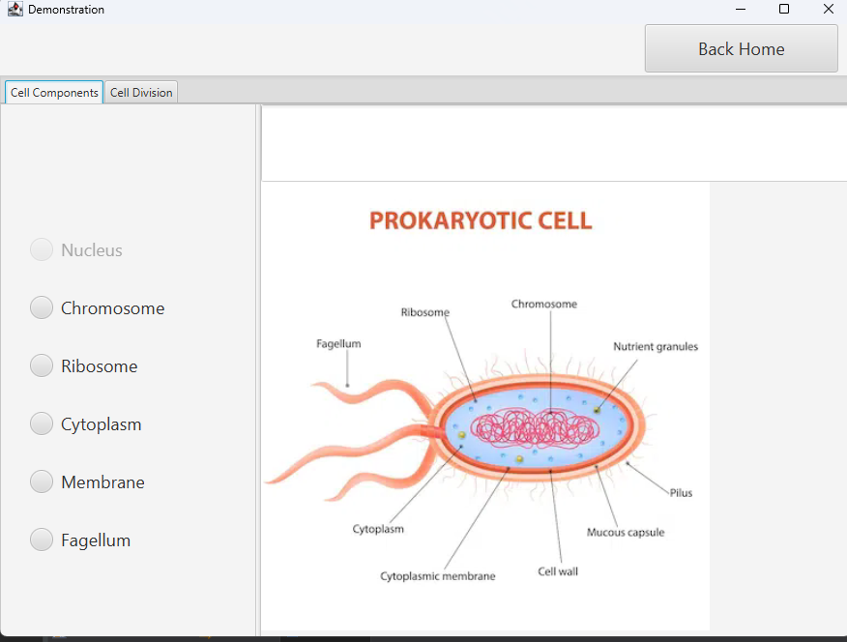**\* Display infection process**

Similarly with structure, the user can move on “Cell Division” , then click to see the Demonstration of cell division. Denote that there are many stages in Demonstration of cell divisionthen the user can interact with the software by choosing arbitrary stage, and the software will return the result by corresponding text and image:

# 3. Design

## 3.1. General class diagram

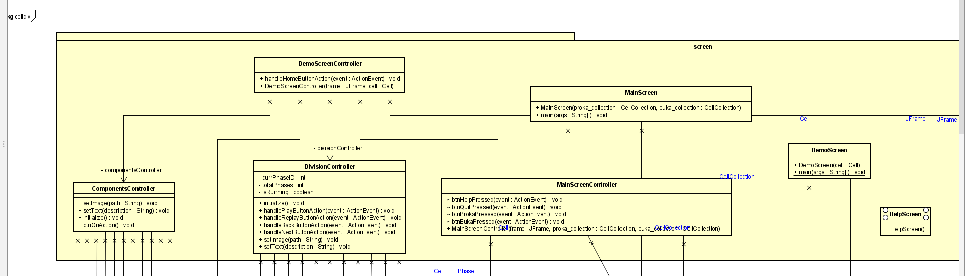

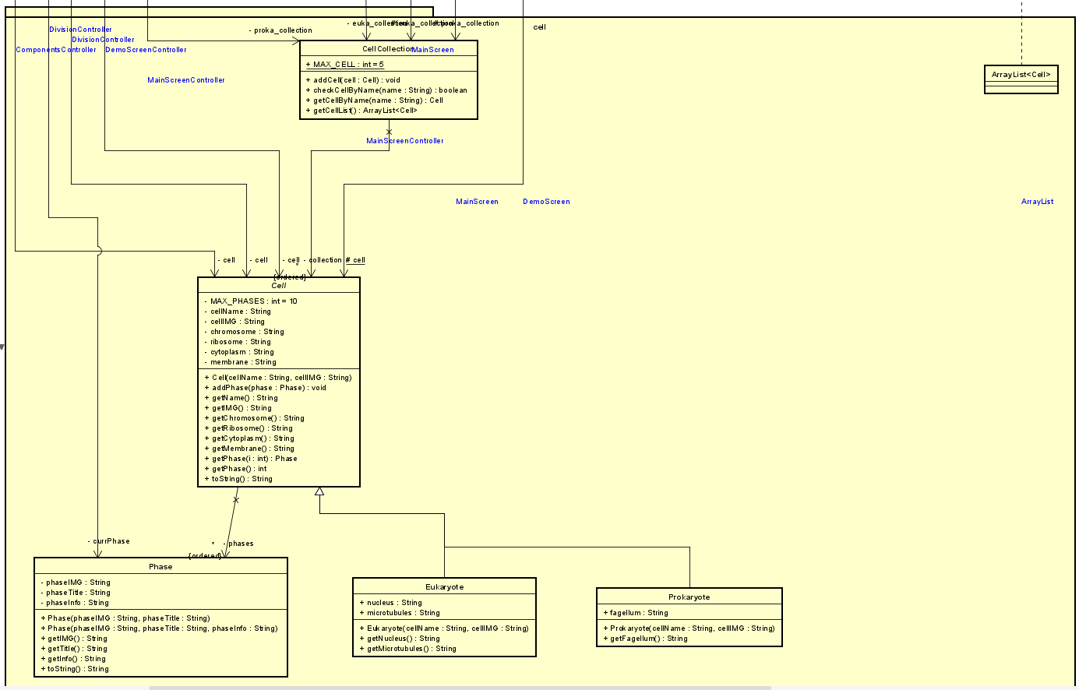

## 3.2 Implementations of Important Methods

Key methods have been implemented to retrieve attributes of Cell objects and visually represent cell division progress on the Demo Screen.

Cell Class and Inherited Classes:

* Getter methods: Methods, such as getIMG() and getChromosome(), get image and component descriptions of Cell objects, including their inherited classes Prokaryote and Eukaryote.
* AddPhase() method: This method enables the addition of phases to specific Cell objects, as each type of cell division involves different phases.

Phase Class:

* Getter methods: Methods like getIMG() and toString() retrieve information related to cell division phases.

ComponentsController Class:

* btnOnAction() method: This method updates information for the selected cell component based on user interactions.

 DivisionController Class:

* Button Action Handling methods: Methods such as handlePlayButtonAction() ensure that the image, information, and progress bar of the current cell phase are updated appropriately in response to user interactions. To ensure smooth GUI updates from non-GUI controller threads, Platform.runLater() is deployed. This mechanism queues updates to be handled by the GUI thread as soon as possible, maintaining responsiveness and preventing potential threading issues.

## 3.3 Technical Specifications

By utilizing the following tools, the team's application conducts data crawling, constructs a user interface, and interacts with users:

* Java Programming Conventions: Standardization of classes, packages, variable names, and functions in Java.
* Building class and package diagrams using UML and Asta.
* JavaFX and Scene Builder: Designing the interface using JavaFX, a modern UI Framework that facilitates user interaction. JavaFX offers various UI controls and layouts to build the application interface and its components."

# 4. Simulation

* Installation Guide
* Users are advised to run the application using Github and Git by following these steps:
* Download the repository link or clone the project to your personal machine by entering the following command in the terminal at the desired storage location: "git clone https://github.com/cuisinecometwot/OOLT.VN.20231-08.git".
* Run the application using the main class "sourcecode\celldiv\screen\MainScreen.java".
* Finally, enjoy the application."